Lab # 5

C++ Loop Control Structure

Playing with loops makes programming fun. Before we try to understand loop, you should be thorough with all the previous topics of C++.

Suppose, we have to print the first 10 natural numbers.

One way to do this is to print the first 10 natural numbers individually using cout. But what if you are asked to print the first 100 natural numbers! You can easily do this with the help of loops.

Loops are used in programming to repeat a specific block of code**.**

Broadly classifying, there are three types of loops in C++ which are:

1. For Loop

There may be a situation, when you need to execute a block of code several number of times. In general, statements are executed sequentially: The first statement in a function is executed first, followed by the second, and so on.

Programming languages provide various control structures that allow for more complicated execution paths.

A loop statement allows us to execute a statement or group of statements multiple times and following is the general from of a loop statement in most of the programming languages

Syntax:

**for(initialization; condition; propagation)  
{  
    statement(s)  
}**

**How for loop works?**

1. The initialization statement is executed only once at the beginning.
2. Then, the test expression is evaluated.
3. If the test expression is false, for loop is terminated. But if the test expression is true, codes inside body of for loop is executed and update expression is updated.
4. Again, the test expression is evaluated and this process repeats until the test expression is false.

Flowchart:

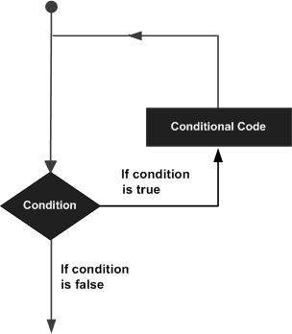

Example

# include <iostream>

int main()

{

using namespace std;

int n ;

for(n = 1; n <= 10 ; n++ )

{

cout<< n << endl;

}

return 0;

}

## while Loop

A **while** loop statement repeatedly executes a target statement as long as a given condition is true.

## Syntax

The syntax of a while loop is:

while (condition)

{

statement;

}

### How while loop works?

* The while loop evaluates the test expression.
* If the test expression is true, codes inside the body of while loop is evaluated.
* Then, the test expression is evaluated again. This process goes on until the test expression is false.
* When the test expression is false, while loop is terminated.

### Flowchart :

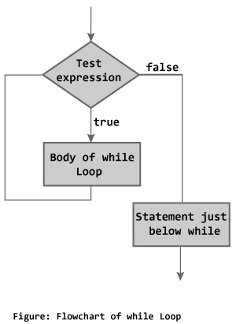

Example :

#include <iostream>

using namespace std;

int main () {

// Local variable declaration:

int a = 10;

// while loop execution

while( a < 20 ) {

cout << "value of a: " << a << endl;

a++;

}

return 0;

}

Output:

value of a: 10

value of a: 11

value of a: 12

value of a: 13

value of a: 14

value of a: 15

value of a: 16

value of a: 17

value of a: 18

value of a: 19

## do...while Loop

The do...while loop is a variant of the while loop with one important difference. The body of do...while loop is executed once before the test expression is checked.

Syntax :

The syntax of do..while loop is:

do

{

Statement;

}

while(condition);

### How do...while loop works?

* The codes inside the body of loop is executed at least once. Then, only the test expression is checked.
* If the test expression is true, the body of loop is executed. This process continues until the test expression becomes false.
* When the test expression is false, do...while loop is terminated.

### Flowchart

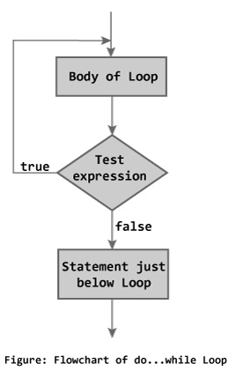

Example :

#include <iostream>

using namespace std;

int main () {

// Local variable declaration:

int a = 10;

// do loop execution

do {

cout << "value of a: " << a << endl;`

a = a + 1;

} while( a < 20 );

return 0;

}

Output:

value of a: 10

value of a: 11

value of a: 12

value of a: 13

value of a: 14

value of a: 15

value of a: 16

value of a: 17

value of a: 18

value of a: 19

Task :

1. Write a program in C++ to check whether a number is prime or not.   
   Sample Output:  
   Input a number to check prime or not: 13  
   The entered number is a prime number.
2. Write a program in C++ to display n terms of natural number and their sum.   
   Sample Output:  
   Input a number of terms: 7   
   The natural numbers upto 7th terms are:   
   1 2 3 4 5 6 7   
   The sum of the natural numbers is: 28
3. Write a program in C++ to display the pattern like right angle triangle with number.   
   Sample Output:  
   Input number of rows: 5   
   1  
   12   
   123   
   1234   
   12345